Lesson 08 Demo 2
Pod Creation in Kubernetes

Objective: To create a Pod using yaml file in Kubernetes.

Tools required: Docker, Kubernetes.

Pre-requisites: You need to have installed Kubernetes and set up a cluster in order to proceed with this demo. If you don’t have it installed, refer to Demo 1 of Lesson 10.

Steps to be followed:
- Creating multi-container pods
- Creating a single container pod

Step 1: Creating multi-container pods
- On the master node, create a new file named sample.yaml:
sudo su
vi sample.yaml
- Add the following code in the sample.yaml file:
apiVersion: v1
kind: Pod
metadata:
name: multi-container
spec:
terminationGracePeriodSeconds: 0
containers:
- name: nginx
image: nginx:1.10-alpine
ports:
- containerPort: 80
- name: alpine
image: alpine:3.5
command: ["watch", "wget", "-qO-", "localhost"]
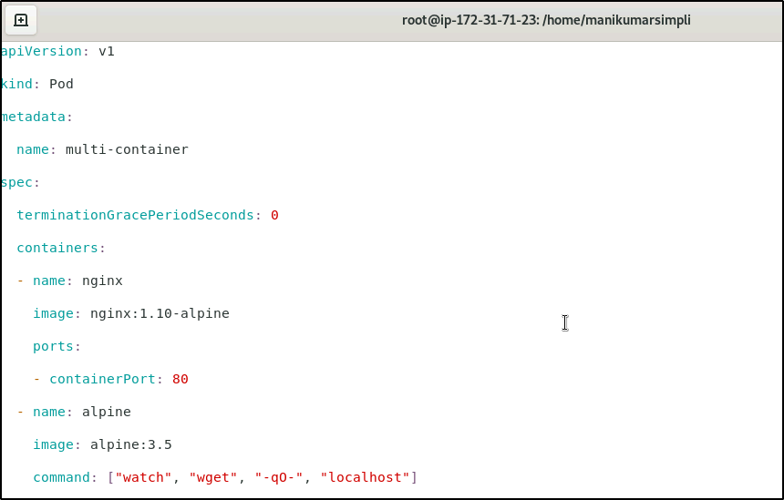

- Use the following command to create the multi-container pod:
kubectl create -f sample.yaml
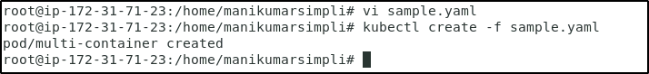

Step 2: Creating a single container pod
- On the master node, create a single container pod with a tomcat image using the following command:
kubectl run tomcat --image=tomcat:8.0

- Check all the running pods
kubectl get pods
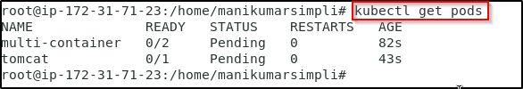
- To check why exactly a pod is in the pending state, run the command
kubectl describe pods <pod_name>
To check why multi-container pod is pending,use the command
kubectl describe pods multi-container
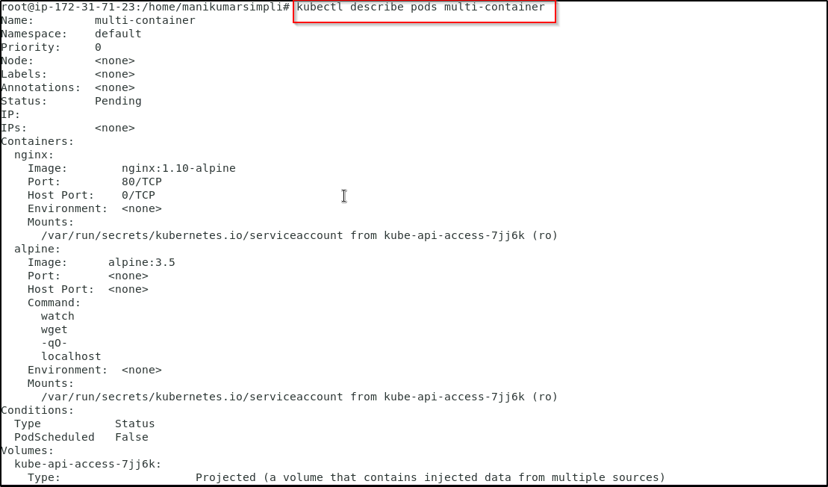
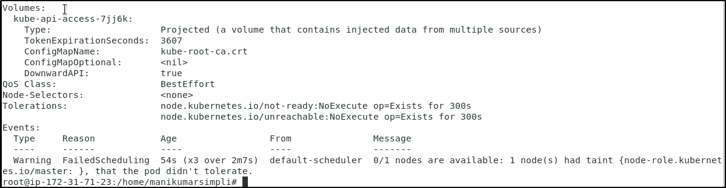
- To remove the taint from the node run the following commands:
kubectl get nodes
Copy the node name and use it in the below command
kubectl taint nodes <node name> node-role.kubernetes.io/master-
Here for example we use the command given below
kubectl taint nodes ip-172-31-18-183 node-role.kubernetes.io/master-
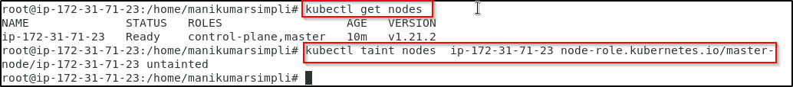
- Now check the pod status. The pods should be in the running state.
sudo kubectl get pods
